**Assignment 2**

**Name:** Rashmi Ravindra Kawale

**ID:** c0779859

1. a) Create a new table for your analysis called “employee_sales”.
2. Load the table “employee” into this table.

c) Select these columns: Attrition, Department, JobSatisfaction & MonthlyIncome.

The new table employee_sales created

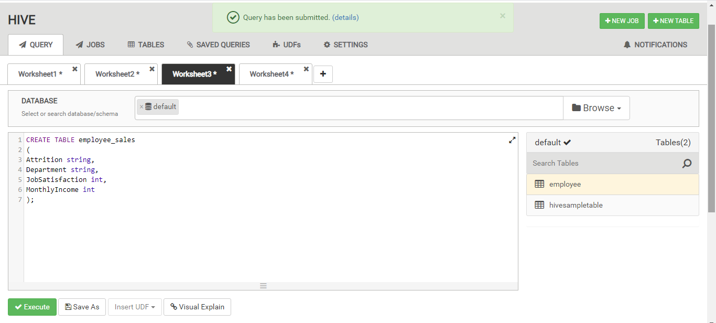

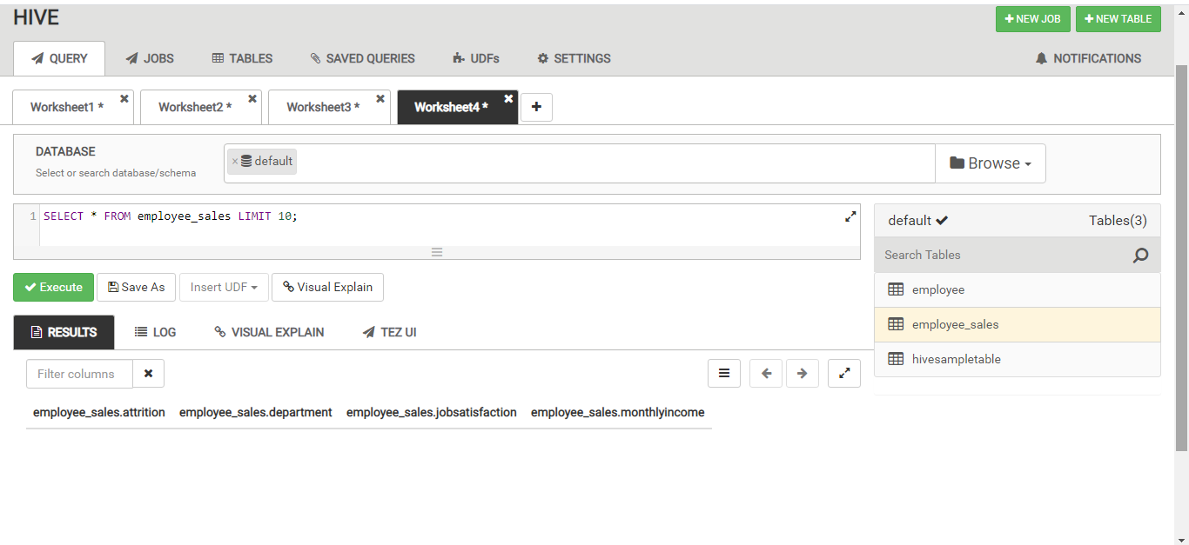

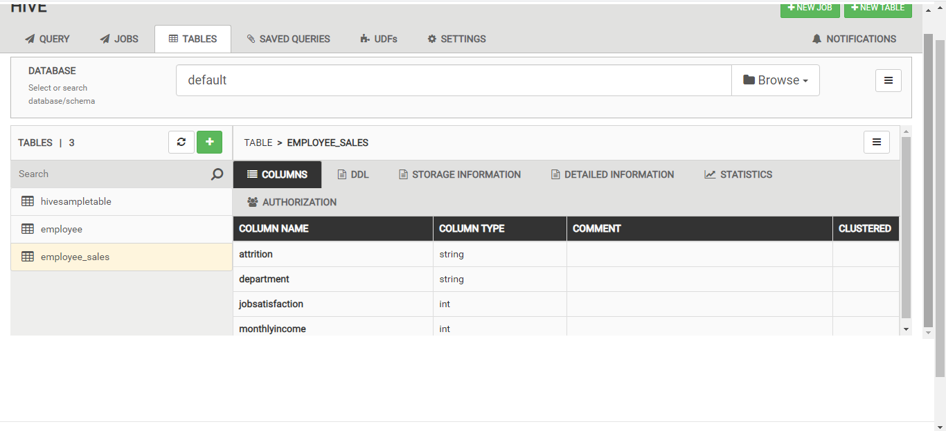

Loaded the table employee to the new table employee_sales:

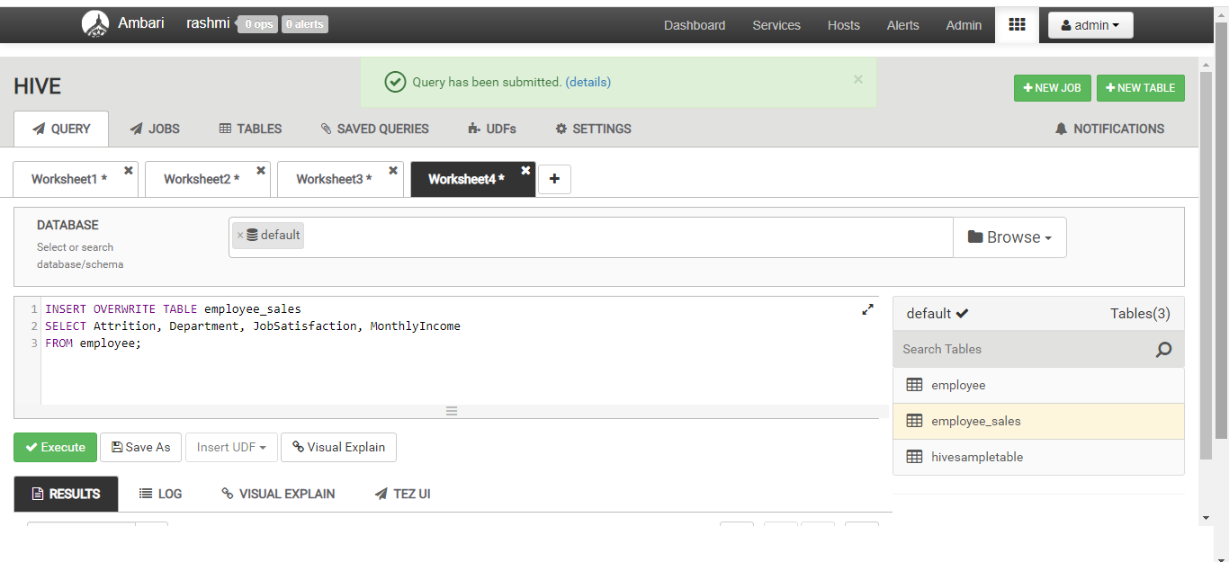

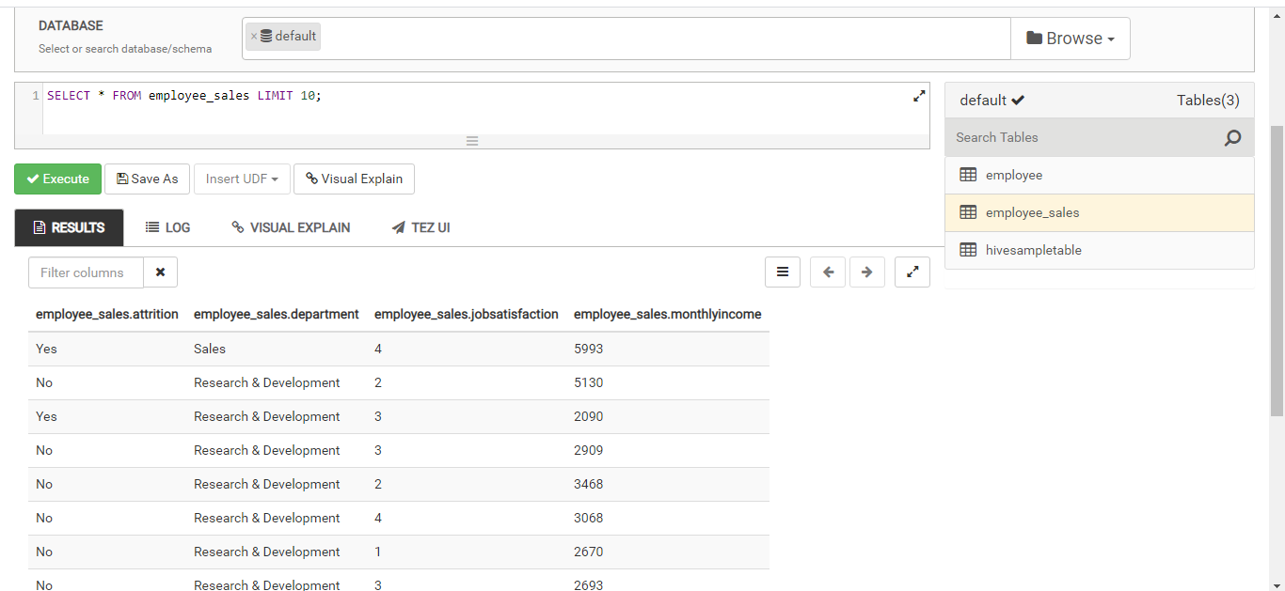

1. Round the data found in the “MonthlyIncome” column to the nearest $1000.

ROUND function is used to calculate nearest $1000 to the data found in the ‘MonthlyIncome’ column and saved the new values in the column MonthlyIncomeValue,

Query:

SELECT ROUND(monthlyincome, -3) As MonthlyIncomeValue

FROM employee_sales;

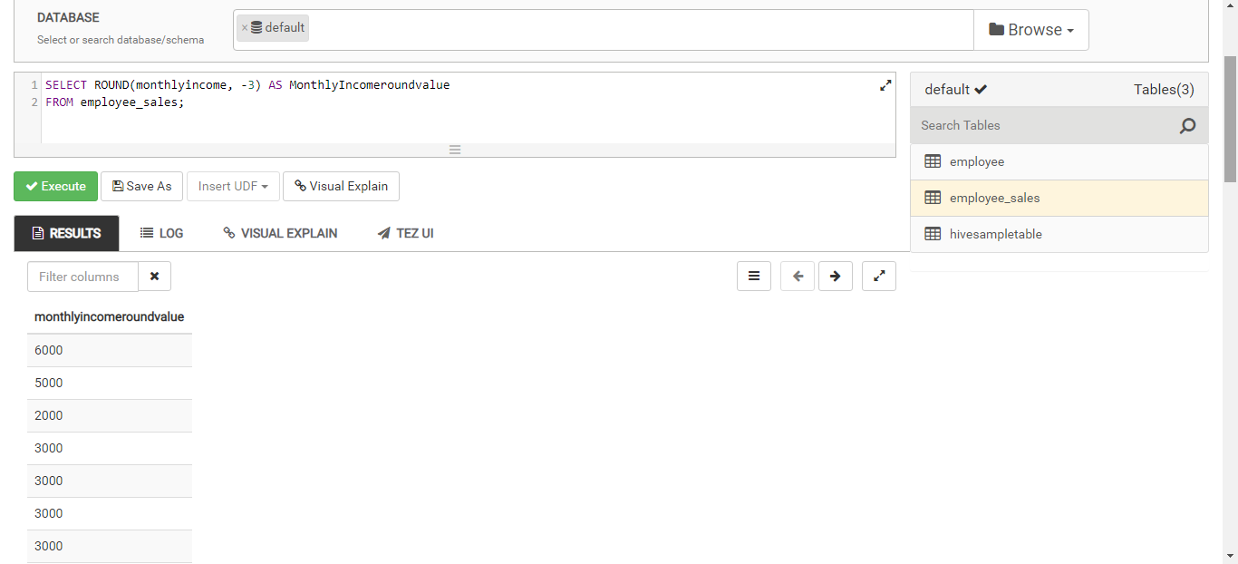

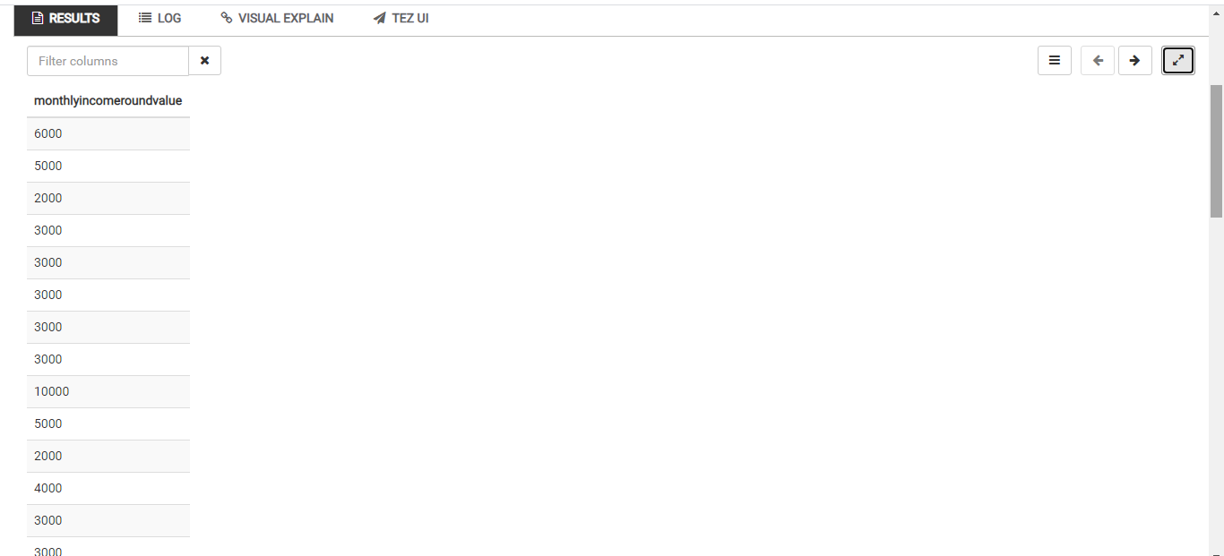

1. Filter the data to only look at those items in the “Sales Department”.

Query:

INSERT OVERWRITE TABLE employee_Sales

SELECT *

FROM employee_sales

WHERE department LIKE “%Sales%”;

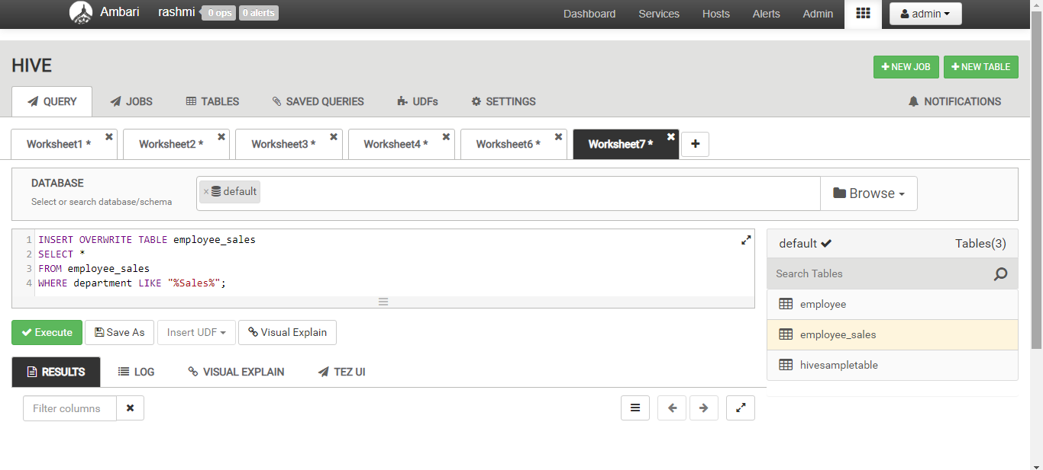

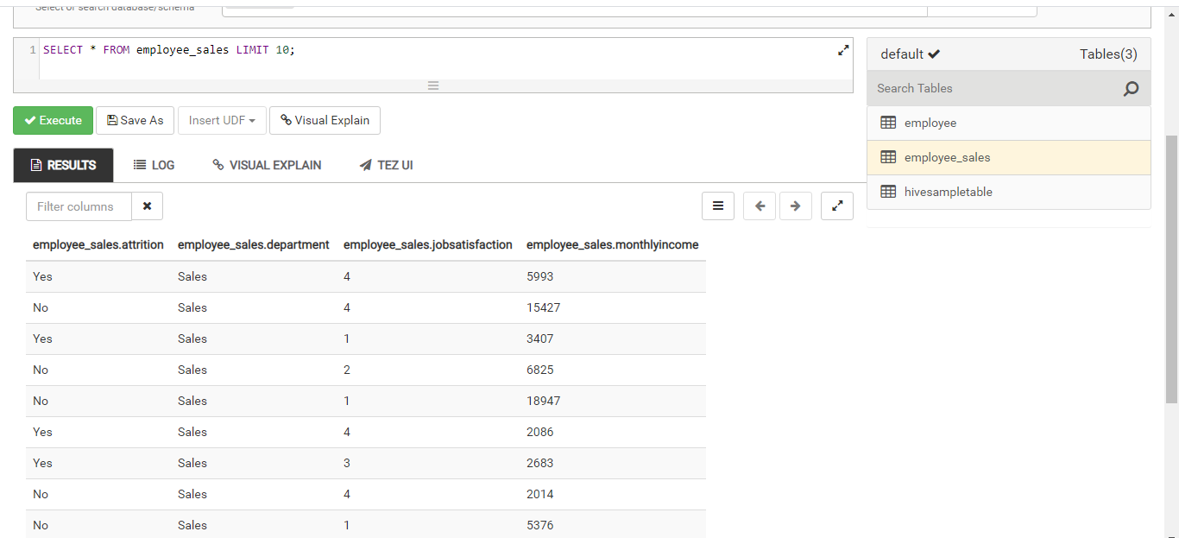

1. Order the data by “JobSatisfaction” from highest to lowest.

Query:

SELECT * FROM employee_sales

ORDER BY jobsatisfaction DESC;

